Turner Syndrome Support Society UK [TSSS]
Invites you to attend the

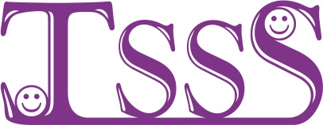

TSSS Oxford Seminar Day

Theme of the day is sharing up to date medical information and services along with patient experiences, from the Oxford TS Specialist Clinic Team

Saturday 25th November 2017
11am until 4pm
OCDEM, Churchill Hospital, Headington, Oxford OX3 7LE
TSSS Committee, doctors, nurses and members will be attending to offer support and information about turner syndrome
For more details call Arlene
Tel 0141 952 8006 Email-Turner.Syndrome@tss.org.uk or www.tss.org.uk
……..……..…….……..…….…….…………..……..…….
BOOKING FORM FOR THE OXFORD SEMINAR DAY ON SATURDAY 25th Nov 2017
OCDEM, Churchill Hospital, University of Oxford, Headington, Oxford OX3 7LE details will be available on www.tss.org.uk and directions will be sent with your confirmation.
Places are limited please book by 1st of NOV 2017
Please book……….place[s] @ £12 per adult [to cover cost of coffee/tea & light lunch]
Please book……….place[s] @ £6 12-16 years per child [to cover cost of coffee/tea & light lunch]
List all names on the reverse of this booking form & give the age[s] of any children
Children over 12 are welcome if fully aware of TS [ No Childcare available]
Cheque should be payable to “Turner Syndrome Support Society”
or pay on via the TSSS shop @www.tss.org.uk
If cost is an issue please contact Arlene she will be able to help
Please in the box if you would like membership information TSSS
Send confirmation to: - Name…………………………………………………….…………………………………………..
Address…………………………………..………………………………………………Post code………………………….
Tel No…………..………………………………E-mail …………………………………………………………………………

Please complete the form and send payment [payable to TSSS] ASAP to Arlene Smyth,
TSSS, 12 Simpson Court, 11 South Ave, Clydebank Business Park, Clydebank G81 2NR Thank you, for further information call Arlene 0141 952 8006 or 07947 554587

Charity Reg No. 1080507/ SCO 37932

