Turner Syndrome Support Society UK [TSSS]
Invites you to attend A TSSS Open Day

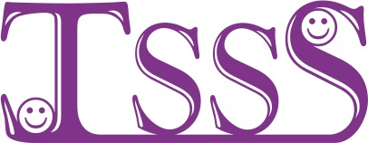

Theme of the day is bringing
TS families together ACROSS
the Newcastle, Gateshead & durham Areas

On Saturday 1st November 2014
11am until 4pm In Lancastrian suite
LANCASTER rd Gateshead tyne & wear NE119JR

TSSS Committee, Local Doctors & nurses will be attending to offer support and information about turner syndrome
For details call Arlene
Tel 0141 952 8006 Email-Turner.Syndrome@tss.org.uk or www.tss.org.uk

……..……..…….……..…….…….…………..……..…….
BOOKING FORM FOR THE NEWCASTLE OPEN DAY ON SATURDAY 1st of NOVEMBER 2014 IN LANCASTRIAN SUITE, LANCASTER ROAD, GATESHEAD, TYNE & WEAR, NE119JR
Pick up and drop off to Metro Centre station available on request

directions will be available on www.tss.org.uk and will be sent with your confirmation letter
Places are limited please book by 1st of OCTOBER 2014
Please book……….place[s] @ £12 per adult [to cover cost of coffee/tea & light lunch]
Please book……….place[s] @ £7 per child [to cover cost of coffee/tea & light lunch]
List all names on the reverse of this booking form & give the age[s] of any children
Cheque should be payable to “Turner Syndrome Support Society”
or pay on via the TSSS shop @www.tss.org.uk
Please in the box if you would like membership information TSSS
Send confirmation to: - Name…………………………………………………….…………………………………………..
Address…………………………………..………………………………………………Post code………………………….
Tel No…………..………………………………E-mail …………………………………………………………………………

Please complete the form and send payment [payable to TSSS] ASAP to Arlene Smyth,
TSSS, 12 Simpson Court, 11 South Ave, Clydebank Business Park, Clydebank G81 2NR Thank you, for further information call Arlene 0141 952 8006 or 07947 554587

Charity Reg No. 1080507/ SCO 37932

