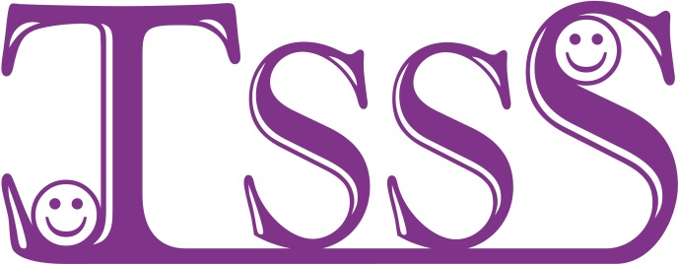
Turner Syndrome Support Society
12 Simpson Court, 11 South Ave,
Clydebank Business Park
Clydebank G81 2NR
Tel 0141-952- 8006
e-mail Turner.Syndrome@tss.org.uk
web www.tss.org.uk
Reg Charity No 1080507/ SCO37932

TSSS Family Fun Weekend 2015 will be at
The Holiday Inn Slough – Windsor on the 8-10th of May 2015

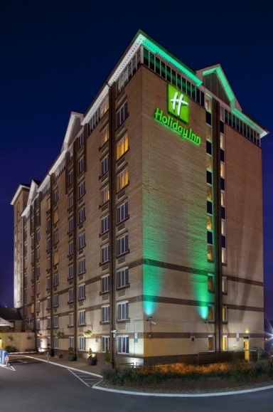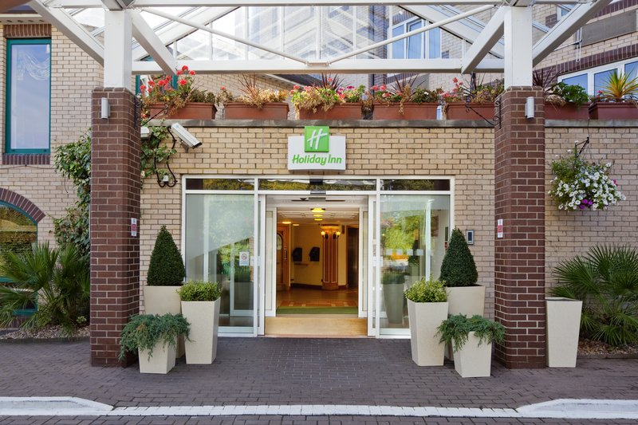

The TSSS are hosting a family fun weekend for members this year. We have chosen to go to Slough as it is close to Windsor and Lego Land and it is only a 30 minute train ride to Paddington in London. So there is a lot of choice you can go to Lego Land for the day [Please book your own tickets for Lego Land]. Visit Windsor Castle have a nice day in the wonderful town of Windsor. Or if you prefer shopping or a show you can pop into London. Everyone is welcome, friends, mums, dads, brothers, sisters, grannies of all ages are welcome to join us. Hopefully there will something for everyone.

You can join us for the whole weekend or you can stay for the Friday or Saturday night only, or just join us for dinner on the Saturday Evening, whatever suits your needs and budget. There is no formal programme, there is a lot to do and the choice is yours.

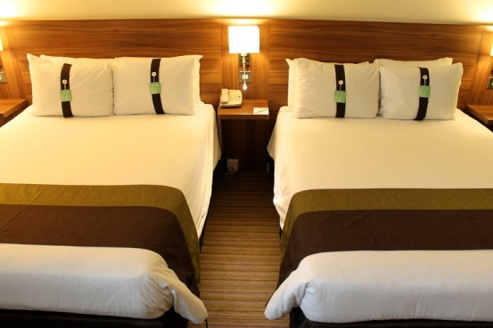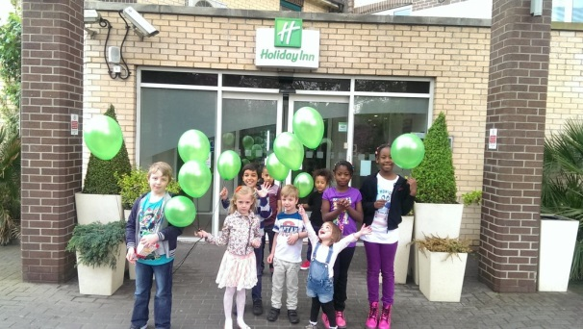

On the Friday Arlene will be available in the hotel to welcome you in our meet and greet room/area from 3pm. We can have a cuppa and a chat. The hotel has a lovely restaurant and spacious bar area for us to meet and chat.

After breakfast on the Saturday morning you are free to do whatever you have chosen to do. In the evening we will have dinner together at 7pm with a chance to chat and get to know each other over the course of the evening.

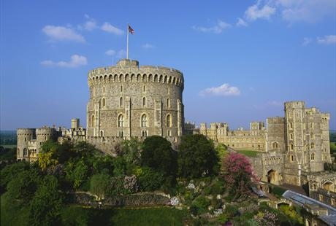
http://www.legoland.co.uk/ http://www.windsor.gov.uk

The hotel sell Lego Land tickets at £39 for an adult & £35 for children (subject to change). If you book online and in advance you get them much cheaper.

On Sunday morning after breakfast we will have the chance to get together for a chat and an opportunity to say our goodbyes.

The best thing about the TSSS is our members who are warm, caring and friendly people who so enjoy being together. It is a chance for the girls to giggle and have fun. For the mums to have a good old natter and for the ladies to swap stories, the dads can enjoy a pint. All this and the chance to have some fun too.

You can call or e-mail Arlene if you have any questions

Booking could not be simpler call The Holiday Inn Hotel on Tel 01753-551551 and ask to book a room from the Turner Syndrome Awareness allocation. Quoting the TSSS will ensure you get the discounted price. The hotel will require your card details to secure your room. Booking deadline is 25th April 2015

The hotel have a limited number of family rooms available, they will be allocated on a first come first served basis, so we advise you to book quickly. They do have interconnecting rooms available too.

As always it is advisable to take out travel insurance to ensure you are covered for any unforeseen events. The TSSS accept no responsibility for your booking. You can call or e-mail Arlene if you have any questions

Prices are detailed on page 3

TSSS Family Fun Weekend in Slough- Windsor
Friday 8th – Sunday 10th May 2015
at the Holiday Inn Hotel, Church St, Chalvey,
Slough, SL1 2NH, Tel 01753-551551.
www.ihg.com › Hotels › Holiday Inn › Slough Hotels

Special Rates for TSSS:

Bed and Breakfast - £55.00 per room per night (maximum 2 adults and 2 children sharing) both Friday and Saturday.
Dinner (Buffet) - £19.50 per adult and £9.95 for Children between 12-16 yrs, kids under 12 stay and eat free. Please book dinner when you are booking your hotel room. Please see attached menus.

The hotel has a small amount of family rooms available, so we advise you to book quickly. They do have interconnecting rooms available too.

Booking could not be simpler call The Holiday Inn Hotel on Tel 01753-551551 and ask to book a room from the Turner Syndrome Awareness allocation. Quoting the TSSS will ensure you get the discounted price. The hotel will require your card details to secure your room. Booking deadline is 25th April 2015

Please e-mail Arlene to confirm your booking at the special discounted rate. We will need the names of all attending and the ages of all the children.

Please call or e-mail Arlene to let us know you are coming. If you have any questions I will be happy to help my mobile no is 07947 554587 if you need to contact me.



Dinner Menu

STARTERS
Soup of the Day
Sea Food Salad
Feta Salad
Tomato, Cucumber & Mixed Leaves

MAINS
Herb Roast Chicken
Beef casserole
Wild mushroom ravioli Pasta
Roasted new potato
Rice/ Steamed Vegetables

DESSERTS
Assorted cake
Chef’s choice dessert
Fruit salad

If you are concerned of any food allergies please ask a member of staff
A 10% discretionary service charge will be added to your bill

CHILDRENS MENU

