Turner Syndrome Support Society UK [TSSS]
Invites you to attend A TSSS Open Day

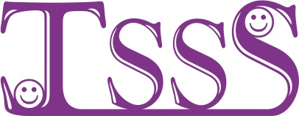

Theme of the day is bringing TS families together ACROSS the Chester AREA

On Saturday 18th June 2016
11am until 4pm
Upton-by-Chester Village Hall
28 Heath Road Chester CH2 1HX

TSSS Committee, Local Doctors & nurses will be attending to offer support and information about turner syndrome
For details call Arlene
Tel 0141 952 8006 Email-Turner.Syndrome@tss.org.uk or www.tss.org.uk

……..……..…….……..…….…….…………..……..…….
BOOKING FORM FOR THE CHESTER OPEN DAY ON SATURDAY 18th of JUNE 2016 IN THE
UPTON-by-CHESTER VILLAGE HALL, 28 HEATH ROAD, CHESTER CH2 1HX
details will be available on www.tss.org.uk and directions will be sent with your confirmation.
Places are limited please book by 1st of June 2016
Please book……….place[s] @ £12 per adult [to cover cost of coffee/tea & light lunch]
Please book……….place[s] @ £6 per child [to cover cost of coffee/tea & light lunch]
List all names on the reverse of this booking form & give the age[s] of any children
Cheque should be payable to “Turner Syndrome Support Society”
or pay online via the TSSS shop @www.tss.org.uk
If cost is an issue please contact Arlene she may be able to help

Please in the box if you would like membership information TSSS
Send confirmation to: - Name…………………………………………………….…………………………………………..
Address…………………………………..………………………………………………Post code………………………….
Tel No…………..………………………………E-mail …………………………………………………………………………

Please complete the form and send payment [payable to TSSS] ASAP to Arlene Smyth,
TSSS, 12 Simpson Court, 11 South Ave, Clydebank Business Park, Clydebank G81 2NR Thank you, for further information call Arlene 0141 952 8006 or 07947 554587

Kindly supported by Pfizer Ltd Charity Reg No. 1080507/ SCO 37932

