Turner Syndrome Support Society UK [TSSS]
Invites you to attend A TSSS Open Day

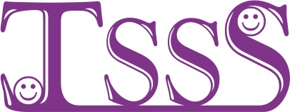

Theme of the day is bringing TS families together ACROSS the Aberdeen Area

On Saturday 18th APRIL 2015
11am until 4pm In Aberdeenshire Cricket Club, Morningside Road, Mannofield, Aberdeen AB10 7FB

TSSS Committee, Local Doctors & nurses will be attending to offer support and information about turner syndrome

All are welcome
For details call Arlene
Tel 0141 952 8006 Email-Turner.Syndrome@tss.org.uk or www.tss.org.uk

……..……..…….……..…….…….…………..……..…….
BOOKING FORM FOR THE ABERDEEN OPEN DAY ON SATURDAY 18th of APRIL 2015 IN ABERDEEDSHIRE CRICKET CLUB, MORNINGSIDE ROAD, MANNOFIELD, ABERDEEN AB10 7FB
Directions will be available on www.tss.org.uk and will be sent with your confirmation letter.

Places are limited please book by 1st of APRIL 2015
Please book……….place[s] @ £12 per adult [to cover cost of coffee/tea & light lunch]
Please book……….place[s] @ £6 per child [to cover cost of coffee/tea & light lunch]
List all names on the reverse of this booking form & give the age[s] of any children
Cheque should be payable to “Turner Syndrome Support Society”
or pay on via the TSSS shop @www.tss.org.uk
If the cost is an issue please contact Arlene she may be able to help
Please in the box if you would like membership information TSSS
Send confirmation to: - Name…………………………………………………….…………………………………………..
Address…………………………………..………………………………………………Post code………………………….
Tel No…………..………………………………E-mail …………………………………………………………………………

Please complete the form and send payment [payable to TSSS] ASAP to Arlene Smyth,
TSSS, 12 Simpson Court, 11 South Ave, Clydebank Business Park, Clydebank G81 2NR Thank you, for further information call Arlene 0141 952 8006 or 07947 554587

Charity Reg No. 1080507/ SCO 37932

